1.)On your Windows laptop or PC, open 'System Information' and take a screenshot showing your OS version, processor, and RAM details.
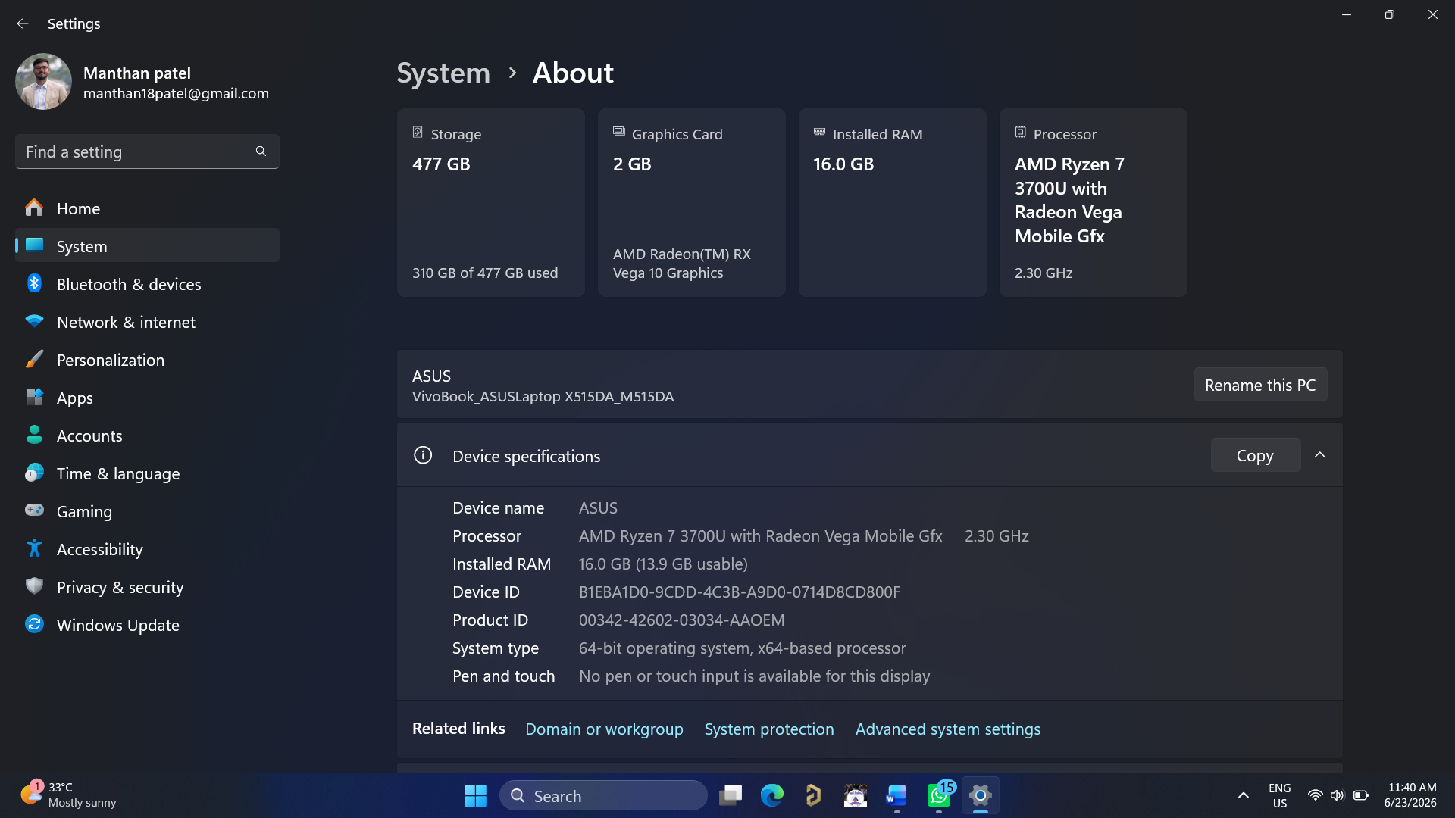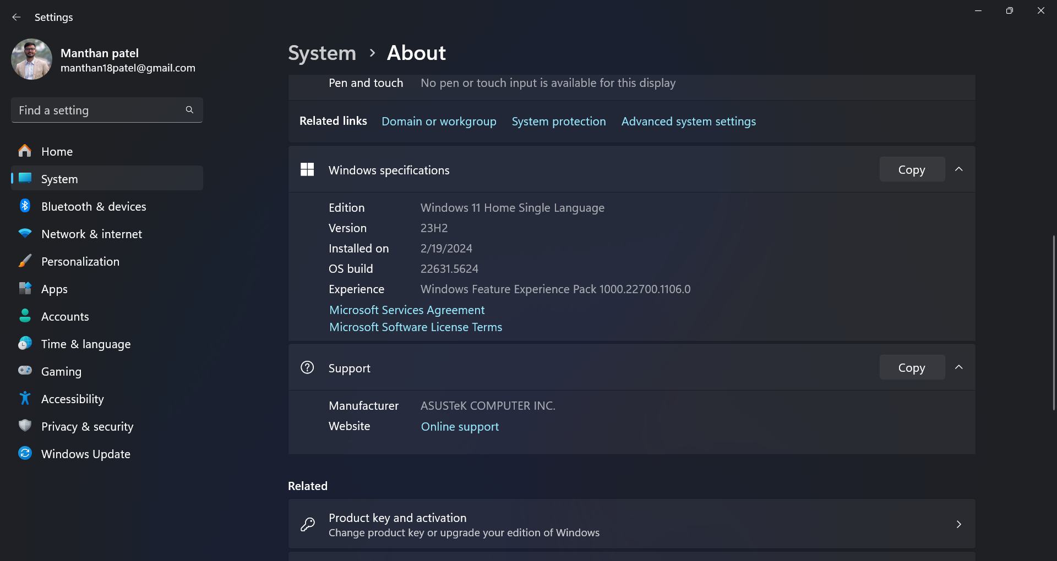

2.Download any official Linux distribution ISO (like Ubuntu or Fedora), and use Rufus or BalenaEtcher to create a bootable USB drive for installation.<br><br><em><strong>Hint:</strong> If you don't have a spare USB, use a virtual machine tool like VirtualBox to mount the ISO and start the installation process virtually.</em>
->Step-by-Step Process for Creating a Bootable Linux USB Drive
- First, I downloaded the latest Ubuntu Linux ISO file from the official Ubuntu website.
- After downloading the ISO file, I installed Rufus on my Windows computer.
- I inserted a USB drive (minimum 8 GB recommended) into the computer.
- I opened Rufus and selected the connected USB drive.
- In Rufus, I clicked on the "Select" button and chose the downloaded Ubuntu ISO file.
- I kept the default settings and clicked on "Start" to begin creating the bootable USB drive.
- After a few minutes, the process was completed successfully, and the bootable USB drive was ready for Linux installation.
Alternative Method (Virtual Machine):
If a spare USB drive is not available, a virtual machine software such as VirtualBox can be used. In VirtualBox, the downloaded ISO file can be mounted as a virtual DVD, and the Linux installation process can be started without using a physical USB drive.
This method allows users to test and install Linux in a virtual environment safely.
3.On a macOS device (or using a macOS virtual machine), open 'System Preferences' and change the desktop wallpaper, then adjust the system language to Hindi or Gujarati.<br><br><em><strong>Hint:</strong> Find 'Language & Region' in System Preferences to add or change languages.</em>

->Changing Wallpaper and System Language in macOS
- I started the macOS system and opened System Preferences from the Apple menu.
- To change the desktop wallpaper, I clicked on Desktop & Screen Saver.
- I selected a new wallpaper from the available images and applied it successfully.
- Next, I returned to the main System Preferences window and opened Language & Region.
- I clicked on the "+" (Add) button under the Preferred Languages section.
- I added Hindi as the new system language and set it as the primary language.
- macOS asked for a restart to apply the changes, so I restarted the system.
- After restarting, the system interface appeared in Hindi, confirming that the language change was successful.
Result: The desktop wallpaper was changed successfully, and the system language was updated to Hindi using the Language & Region settings.
4.Install a fresh copy of Ubuntu Linux (real or virtual machine) and create a new user account named 'gamer'. After installation, enable automatic login for this user and take a screenshot of the login screen showing the username.

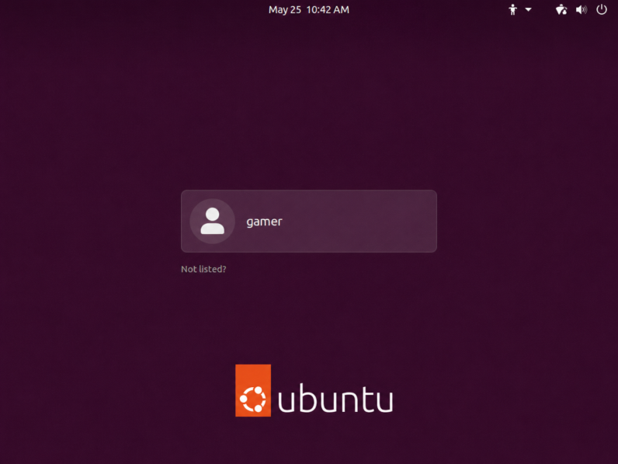

5.Use ChatGPT to generate a step-by-step guide for installing Windows 10 on a laptop, including partitioning tips and post-installation settings for privacy and updates. Follow the guide and note any steps that were unclear or missing.

->Step-by-Step Guide for Installing Windows 10 on a Laptop
- Download Windows 10 ISO
  - Visit Microsoft's official website and download the Windows 10 ISO file.
- Create a Bootable USB Drive
  - Use software such as Rufus to create a bootable USB drive using the downloaded ISO file.
- Boot from the USB Drive
  - Insert the USB drive into the laptop.
  - Restart the laptop and press the boot menu key (such as F12, Esc, F9, or F10 depending on the manufacturer).
  - Select the USB drive as the boot device.
- Start Windows Setup
  - Choose the language, time format, and keyboard layout.
  - Click Next and then click Install Now.
- Enter Product Key
  - Enter the Windows product key if available.
  - If not, select "I don't have a product key" to continue.
- Select Windows Edition
  - Choose the appropriate Windows 10 edition (Home, Pro, etc.) and click Next.
- Accept License Terms
  - Read and accept the Microsoft Software License Terms.
- Choose Installation Type
  - Select Custom: Install Windows only (Advanced) for a fresh installation.
- Partitioning Tips
  - Delete old partitions only if all important data has been backed up.
  - Create a separate partition for Windows (recommended: 100–150 GB).
  - Use another partition for personal files such as documents, photos, and videos.
  - Leave unallocated space if additional partitions are needed later.
  - Be careful not to delete recovery partitions unless necessary.
- Install Windows
  - Select the partition where Windows will be installed and click Next.
  - Wait for the installation process to complete. The system may restart several times.
- Complete Initial Setup
  - Select region and keyboard settings.
  - Connect to a Wi-Fi network if available.
  - Create a local account or sign in with a Microsoft account.

Post-Installation Settings
- Privacy Settings
  - Disable unnecessary diagnostic data sharing.
  - Turn off advertising ID if not required.
  - Review location, microphone, and camera permissions.
- Windows Update
  - Open Settings → Update & Security → Windows Update.
  - Check for updates and install all available updates.
  - Restart the system if prompted.
- Driver Installation
  - Install drivers for graphics, audio, Wi-Fi, and other hardware components if required.
- Install Essential Software
  - Install a web browser, antivirus software, office applications, and other required programs.

Steps That Were Unclear or Missing
- The exact boot menu key varies between laptop manufacturers and may need to be checked beforehand.
- The guide does not explain how to switch between UEFI and Legacy boot modes in BIOS if boot issues occur.
- Backup of important files should be performed before starting the installation process.
- Internet connectivity is recommended during setup to receive updates and drivers automatically.
This guide was generally clear and sufficient for performing a fresh installation of Windows 10 on a laptop.

THE END…….

